


2025 Annual Report of Involuntary Transports
Presented to NYC City Council (Local Law 116 2023)

(Updated May 1, 2026)

Introduction
The Mayor’s Office of Community Mental Health (OCMH) submits the following report to the Honorable Speaker of the New York City Council, Julie Menin pursuant to Local Law 116 (2023). This report tracks the City's use of the legal provisions under Sections 9.41 and
9.58 of the New York State Mental Hygiene Law, which allow for the involuntary transport to an emergency department for psychiatric evaluation for any individual who appears to be mentally ill and is behaving in a manner likely to result in serious harm to themselves or others. Transparency and data-sharing are important to creating a safer and more caring New York City, and OCMH has worked across agencies to comply with this mandate.
Involuntary transport is a process initiated by a clinician, peace officer or police officer, by which an individual is taken into custody for the purpose of transportation to a hospital for psychiatric evaluation. It does not constitute an arrest, as it is not related to criminal charges, but rather is aimed at addressing immediate mental (and sometimes physical) health needs. Involuntary transports do not equate to involuntary hospitalization.

Throughout this report, two types of involuntary transports will be referenced:
- Transport under New York Mental Hygiene Law § 9.41, initiated by a police officer or peace officer upon determining that an observed individual meets the legal criteria.
- Transport under New York Mental Hygiene Law § 9.58, initiated by a certified physician or mental health professional upon determining that an observed individual meets the legal criteria and effectuated with police assistance.
The report will refer to transports to the emergency department for psychiatric evaluation pursuant to §
9.41 as “police-initiated transports” and transports pursuant to § 9.58 as “clinician-initiated transports.”
The number of involuntary transports is not equivalent to the number of people involuntarily transported, as an individual may be involuntarily transported multiple times. Data for how many unique individuals have been involuntarily transported is not available, as responding clinicians and officers are unable to gather personal and biographical information of each person, as they are often in the middle of a mental health crisis.
The report tracks involuntary transports across agencies, such as the New York City Police Department (NYPD), Metropolitan Transit Authority Police Department (MTA PD), New York City Department of Social Services (DSS), New York City Department of Health and Mental Hygiene (DOHMH), and New York City Health + Hospitals Corporation (H+H). The goal of the report is to increase transparency and share how the City and MTA are using this statutory authority to connect New Yorkers with emergency mental health support when needed.
Local Law 116 calls for the City to report data on the age, gender, race, ethnicity, and living situation of persons subject to involuntary transport. However, individuals in the midst of mental health crisis are often unable to share such details before or while being transported. For personnel effectuating transports, the need to complete their task safely and quickly must take precedence over the collection of biographical information. Accordingly, much of the biographical data reported are unverified impressions of the officer or clinician and may be incomplete, inaccurate, and/or inconsistent with how the person being transported self-identifies

2025 Annual Data on Officer-initiated and Clinician-Initiated Involuntary Transports

The number of involuntary transports conducted pursuant to subdivision (a) of section 9.41 of the Mental Hygiene Law: 7,299*
An officer-initiated transport may occur when an individual experiencing a mental health emergency is involuntarily transported to a hospital, typically by ambulance, after a police officer or peace officer determines that the person appears to be mentally ill and is conducting themselves in a manner likely to result in serious harm to the person or others, as authorized under the Mental Hygiene Law Article 9.
Data for this metric is collected and reported by NYPD and MTA PD.

* 7,299 is the number of officer-initiated transports that occurred, not the number of individuals transported.

The number of involuntary transports conducted pursuant to subdivision (a) of section 9.58 of the Mental Hygiene law: 1,408
A clinician-initiated transport under section 9.58 of Mental Hygiene law may occur when a designated clinician determines that an individual appears to be mentally ill and that their conduct may cause serious harm to themselves or others. In such cases, the individual is involuntarily transported to a hospital, typically by ambulance, in coordination with police. 9.58 Designated Clinicians may direct the transport of any person to a hospital for the purpose of evaluation for admission.
A Section 9.58 Designated Clinician is either a physician or one of the following professionals who is a member of an approved mobile crisis outreach team^{i} approved by the State Commissioner of Mental Health: a licensed psychologist, registered professional nurse, or a licensed master social worker under the supervision of a physician, psychologist or licensed clinical social worker.
Data for this metric is tracked and reported by DOHMH and DSS.
*1,408 is the number of clinician-initiated transports that occurred, not the number of individuals transported.

DOHMH data on clinician-initiated involuntary transports has a three-month reporting lag.

The number of 911 (radio) calls that resulted in the involuntary transport or transportation of an individual: 6,304
A radio run refers to a request for service dispatched over the police radio system. The dispatcher directs officers on patrol over their radios to respond to a specific incident. These are typically received as 911 calls. This data is only available by NYPD and only reported for NYPD officer-initiated involuntary transports.
For the purposes of this report, we are using NYPD radio calls that resulted in an officer-initiated transport as a proxy for 911 calls.
Data for this metric is collected and reported by NYPD.

Information, in the aggregate, regarding the borough and precinct from which individuals subject to involuntary transport were moved, including whether an individual was transported from a private dwelling or a public space, such as a park or the public transportation system, or temporary emergency housing

The following charts show, in aggregate, the location types—Public Space, Private Dwelling, or Public Transportation- and borough/ precincts for involuntary transports conducted by DSS Outreach Teams, NYPD officers and MTA PD officers. These numbers combine statistics from multiple outreach teams and law enforcement in order to protect Personal Identifiable Information (PII).

For the purpose of this data each location type includes:

  - Public Space: A place that is open and accessible to the general public. Public spaces may include a park, the street, or city owned building. The following categories reported by NYPD constitute public space: commercial, house of worship, school. For the purpose of this data, subways or buses operated by MTA are captured under “public transportation”.
  - Private Dwelling: A residential unit that is occupied by one household and is used solely for private residential purposes. This excludes accommodations used for business, public access, or communal living. For data reported by DSS, Transitional Housing is a form of private dwelling. For data reported by NYPD, Temporary emergency housing is a form of private dwelling.
  - Public Transportation: Subways or buses operated by the MTA. This includes subway and bus stations and the inside and outside of buses and trains. Data for public transportation location is reported by MTA PD and DHS.

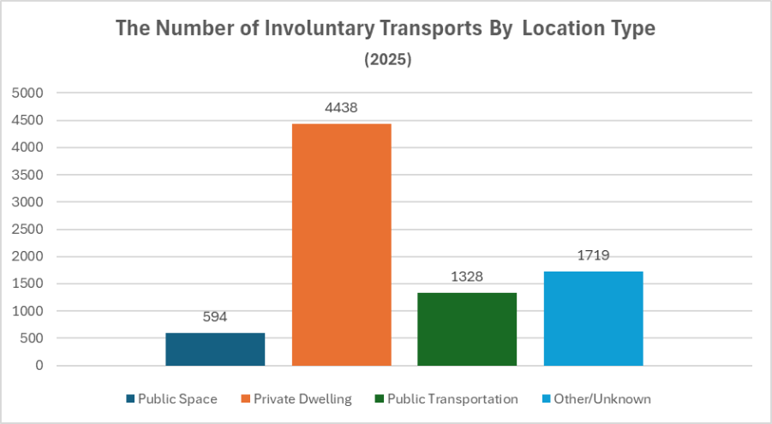

Data for this metric is reported by DSS, NYPD and MTA PD. DOHMH does not collect this data for their reported clinician-initiated involuntary transports.

The following charts show a combination of both clinician-initiated and officer-initiated involuntary transports in aggregate by borough and by precinct.

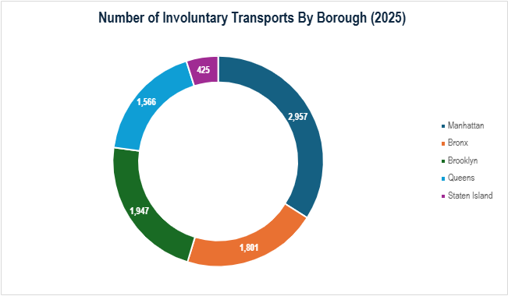

DOHMH data on clinician-initiated involuntary transports has a three-month reporting lag. 11 transports were conducted outside of NYC boroughs and are not included in this data chart.
Borough | Precinct | Total Involuntary  Transports
Manhattan | Pr-1 | 229
Manhattan | Pr-5 | 70
Manhattan | Pr-6 | 94
Manhattan | Pr-7 | 116
Manhattan | Pr-9 | 110
Manhattan | Pr-10 | 348
Manhattan | Pr-13 | 79
Manhattan | Pr-14 | 351
Manhattan | Pr-17 | 134
Manhattan | Pr-18 | 149
Manhattan | Pr-19 | 147
Manhattan | Pr-20 | 99
Manhattan | Pr-22 | 6
Manhattan | Pr-23 | 85
Manhattan | Pr-24 | 90
Manhattan | Pr-25 | 210
Manhattan | Pr-26 | 56
Manhattan | Pr-28 | 117
Manhattan | Pr-30 | 70
Manhattan | Pr-32 | 63
Manhattan | Pr-33 | 122
Manhattan | Pr-34 | 96
Bronx | Pr-40 | 273
Bronx | Pr-41 | 68
Bronx | Pr-42 | 123
Bronx | Pr-43 | 142
Bronx | Pr-44 | 184
Bronx | Pr-45 | 77
Bronx | Pr-46 | 211
Bronx | Pr-47 | 86
Bronx | Pr-48 | 202
Bronx | Pr-49 | 69
Bronx | Pr-50 | 77
Bronx | Pr-52 | 142
Brooklyn | Pr-60 | 158
Brooklyn | Pr-61 | 45
Brooklyn | Pr-62 | 31
Brooklyn | Pr-63 | 54
Brooklyn | Pr-66 | 46
Brooklyn | Pr-67 | 103
Brooklyn | Pr-68 | 67

Brooklyn | Pr-69 | 45
Borough | Precinct | Total Involuntary  Transports
Brooklyn | Pr-70 | 118
Brooklyn | Pr-72 | 70
Brooklyn | Pr-73 | 158
Brooklyn | Pr-75 | 179
Brooklyn | Pr-76 | 25
Brooklyn | Pr-77 | 107
Brooklyn | Pr-78 | 61
Brooklyn | Pr-79 | 89
Brooklyn | Pr-81 | 57
Brooklyn | Pr-83 | 74
Brooklyn | Pr-84 | 107
Brooklyn | Pr-88 | 54
Brooklyn | Pr-90 | 58
Brooklyn | Pr-94 | 56
Queens | Pr-100 | 58
Queens | Pr-101 | 83
Queens | Pr-102 | 84
Queens | Pr-103 | 196
Queens | Pr-104 | 52
Queens | Pr-105 | 122
Queens | Pr-106 | 68
Queens | Pr-107 | 71
Queens | Pr-108 | 62
Queens | Pr-109 | 114
Queens | Pr-110 | 49
Queens | Pr-111 | 41
Queens | Pr-112 | 41
Queens | Pr-113 | 55
Queens | Pr-114 | 131
Queens | Pr-115 | 81
Queens | Pr-116 | 78
Staten Island | Pr-120 | 118
Staten Island | Pr-121 | 109
Staten Island | Pr-122 | 61
Staten Island | Pr-123 | 56
 |  | 8073

Data for DOHMH’s clinician-initiated transports is not available by precinct and is not included in this data chart. 11 transports were conducted outside of NYC boroughs and are not included in this data chart.

Perceived demographic information, in the aggregate, of individuals subject to involuntary transport, including age, race and ethnicity¹, disability status
Obtaining accurate demographic information during a mental health emergency can be challenging as individuals may not communicate for a number of reasons, including distress or an unwillingness to provide details due to fear, mistrust, language barriers or lack of awareness. In such cases, immediate care takes priority over data collection, leaving gaps in information.
Data for this metric is based on the perceptions of the clinician and/or officer initiating an involuntary transport and may not reflect the way an individual self-identifies.

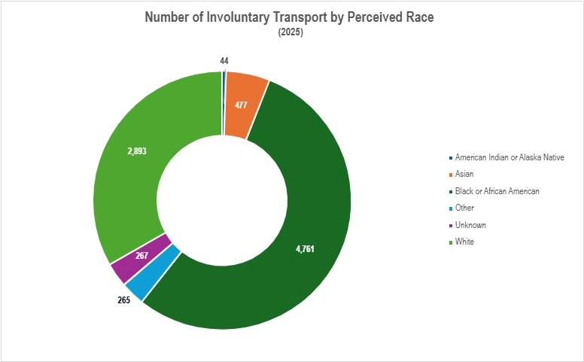

Note DOHMH data on clinician-initiated involuntary transports has a three-month reporting lag.

¹ Data Source and Limitations - Race/Ethnicity: The data presented in this report is an aggregation of information from four agencies: NYPD, MTA, DOHMH and DHS. It is important to note that these agencies do not collect and report race and ethnicity data uniformly.
For ethnicity, four categories are used: Hispanic or Latino, Not Hispanic or Latino, Unknown, and Other. Notably, NYPD does not collect ethnicity data. However, their racial categories include "Black Hispanic" and "White Hispanic." For the purpose of this report, these categories have been included in the "Hispanic" ethnicity category. All other racial categories – excluding "other" and "Unknown" – reported by NYPD have been aggregated into the "Not Hispanic or Latino" ethnicity category.
With respect to race, we have combined "Black" and "Black Hispanic" into a single "Black" category. Similarly, "White" and "White Hispanic" have been combined into a single "White" category.
Further complicating matters, DHS reports "Hispanic or Latino" as a category for both race and ethnicity. To maintain ethical data reporting practices and avoid double-counting, as there is no separate "Hispanic" category under race, we have grouped these responses under the "Other" race category for this report.
These inconsistencies in data collection and the subsequent aggregation may affect the accuracy and granularity of any analysis related to race and ethnicity.
DOHMH data for clinician-initiated involuntary transports is not included in race and ethnicity graphs

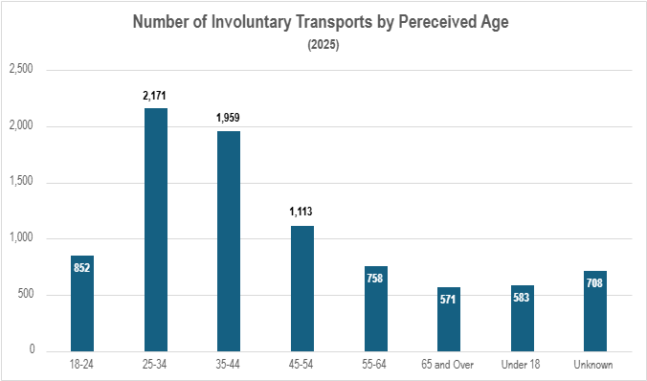
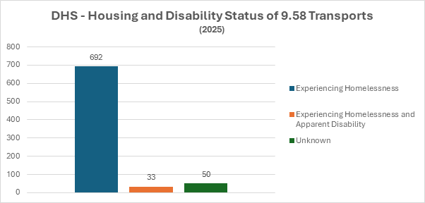

NYPD - Housing and Disability Status of 9.41 Transports
(2025)
6,000
5,000
4,000
3,000
5,389
2,000
1,397
1,000
0
245
41
Apparent Disability
Both
Experiencing Homelessness
Unknown

Information, in the aggregate, regarding whether individuals subject to involuntary transport were transported, and, where available, were admitted, to a hospital, and if so, the names and addresses of each hospital to which such individuals were transported or admitted.

Hospital admission decisions are made by an attending physician on the staff of a hospital. Admission to the hospital refers to inpatient treatment and can be medical or psychiatric. Hospital admission does not include periods of observation, evaluation and/or treatment in an emergency unit of a hospital.
The NYC Health + Hospitals admissions data only includes data based on clinician-initiated transports where NYC Health + Hospitals is informed through email by the clinician-initiated Designated Clinician. We do not have access to outcome data for private hospital networks in the city, where involuntary transports are also taken.

Outcomes for Individuals Transported to
NYC Health + Hospitals Subject to Clinician-Initiated Involuntary Transports (2025)
52%
48%
Admitted for Inpatient Treatment at a NYC Health + Hospitals Facility
Treated and Released and Not Admitted for Inpatient Treatment at a NYC Health + Hospitals Facility

Names of Hospitals That Received Involuntarily Transported Individuals
Note: Data regarding hospitals transported to was not available for clinician-initiated transports reported by DOHMH. DOHMH can report this information for 2025 by April 2026.

Hospital Name | Total Involuntary Transports (2025)
NYC Health + Hospitals/Bellevue | 1175
St. Barnabas Hospital | 437
NYC Health + Hospitals/Lincoln | 435
Queens Hospital Center | 392
NYC Health + Hospitals/Woodhull | 372
Mount Sinai Hospital | 361
NYC Health + Hospitals/Harlem | 333
NYC Health + Hospitals/Kings County | 330
NYC Health + Hospitals/Jacobi | 281
NYC Health + Hospitals/Elmhurst | 272
NYC Health + Hospitals/South Brooklyn Health, Ruth Bader Ginsburg Hospital | 259
Jamaica Hospital Medical Center | 252
Richmond University Medical Center | 250
Brookdale Hospital Medical Center | 247
NYC Health + Hospitals/Metropolitan | 218
Mount Sinai Morningside | 203
New York-Presbyterian Brooklyn Methodist Hospital | 188
BronxCare Hospital Center | 186
New York-Presbyterian/Columbia University Irving Medical Center | 175
Interfaith Medical Center | 158
Maimonides Medical Center | 136
St. John's Episcopal Hospital South Shore | 132
New York-Presbyterian/Weill Cornell Medical Center | 128
Montefiore Medical Center | 118
NYU Langone Hospital—Brooklyn | 96
Mount Sinai Beth Israel | 90
New York-Presbyterian Hospital | 89
Zucker Hillside Hospital | 79
North Central Bronx Hospital | 73
Staten Island University Hospital | 60
Bronx Psychiatric Center | 53
Unknown | 53
Long Island Jewish Medical Center | 47
New York Hospital | 36
Staten Island University Hospital – South | 30
Mercy Hospital | 27

Hospital Name | Total Involuntary Transports (2025)
North Shore University Hospital | 26
Lenox Hill Hospital | 24
NYU Langone Health | 23
BronxCare Hospital Center - Fulton | 19
New York-Presbyterian Lower Manhattan Hospital | 17
Brooklyn Jewish Hospital and Medical Center | 16
New York-Presbyterian Queens | 15
Wyckoff Heights Medical Center | 14
Brooklyn Hospital Center - Downtown Campus | 12
Montefiore Mount Vernon Hospital | 10
Mount Sinai Queens | 10
Montefiore Med Center - Jack D Weiler Hosp of A Einstein College Div | 9
New York-Presbyterian Allen Hospital | 9
St. John’s Riverside Hospital | 9
Long Island Jewish Valley Stream | 8
Cornerstone of Medical Arts Center Hospital | 7
Flushing Hospital Medical Center | 7
Mount Sinai West | 7
SUNY Downstate Medical Center | 6
Westchester Square Campus-Montefiore Medical Center | 6
Brooklyn Hospital Center Caledonian Campus | 5
Other | 5
Long Island College Hospital | 4
Maimonides Midwood Community Hospital | 4
St. Joseph's Hospital - Yonkers | 4
Wakefield Division of Montefiore | 4
Mount Sinai Brooklyn | 3
New York Presbyterian Hospital | 3
Brooklyn Hospital Center | 2
Manhattan Psychiatric Center | 2
New York-Presbyterian Hudson Valley Hospital | 2
Brooklyn VA Medical Center | 1
Coler Specialty Hospital | 1
NYC Health + Hospitals/South Brooklyn Health, Ruth Bader Ginsburg Hospital | 1
Creedmoor Psychiatric Center | 1
Goldwater Memorial Hospital | 1
H.I.P. Hospital Inc | 1
James J. Peters Department of Veterans Affairs Medical Center | 1
Kingsbrook Jewish Medical Center | 1

Hospital Name | Total Involuntary Transports (2025)
Laguardia Hospital | 1
Margaret Cochran Corbin VA Campus | 1
Memorial Hospital for Cancer and Allied Diseases | 1
Montefiore Moses Hospital | 1
Montefiore New Rochelle Hospital | 1
North Shore University Hospital at Glen Cove | 1
NYU Langone Hospital—Long Island | 1
St. Albans Naval Hospital | 1

